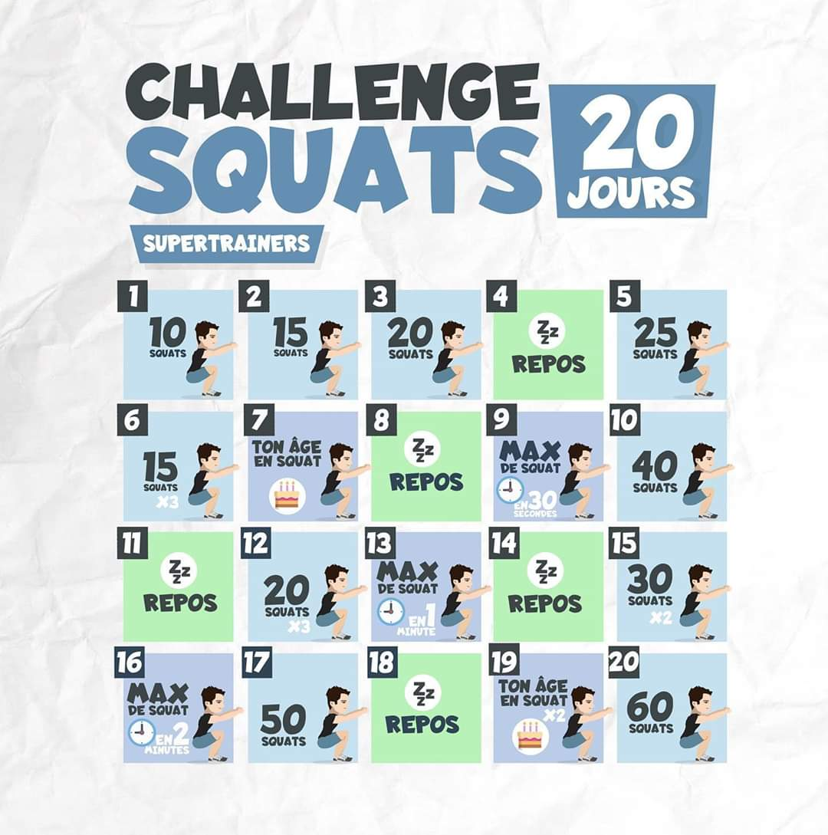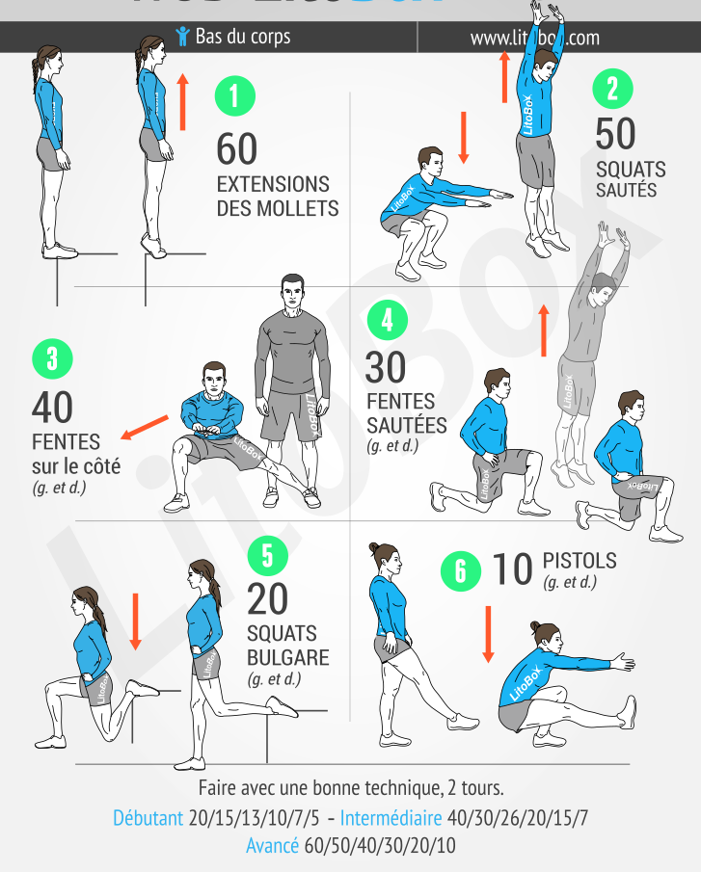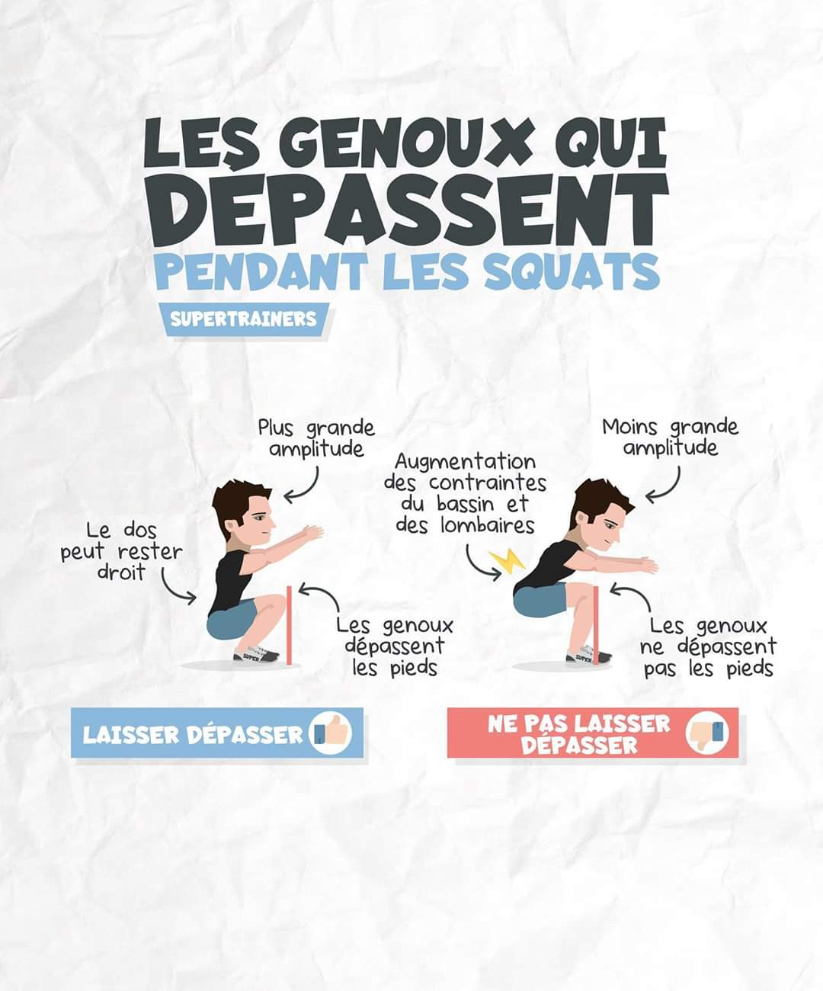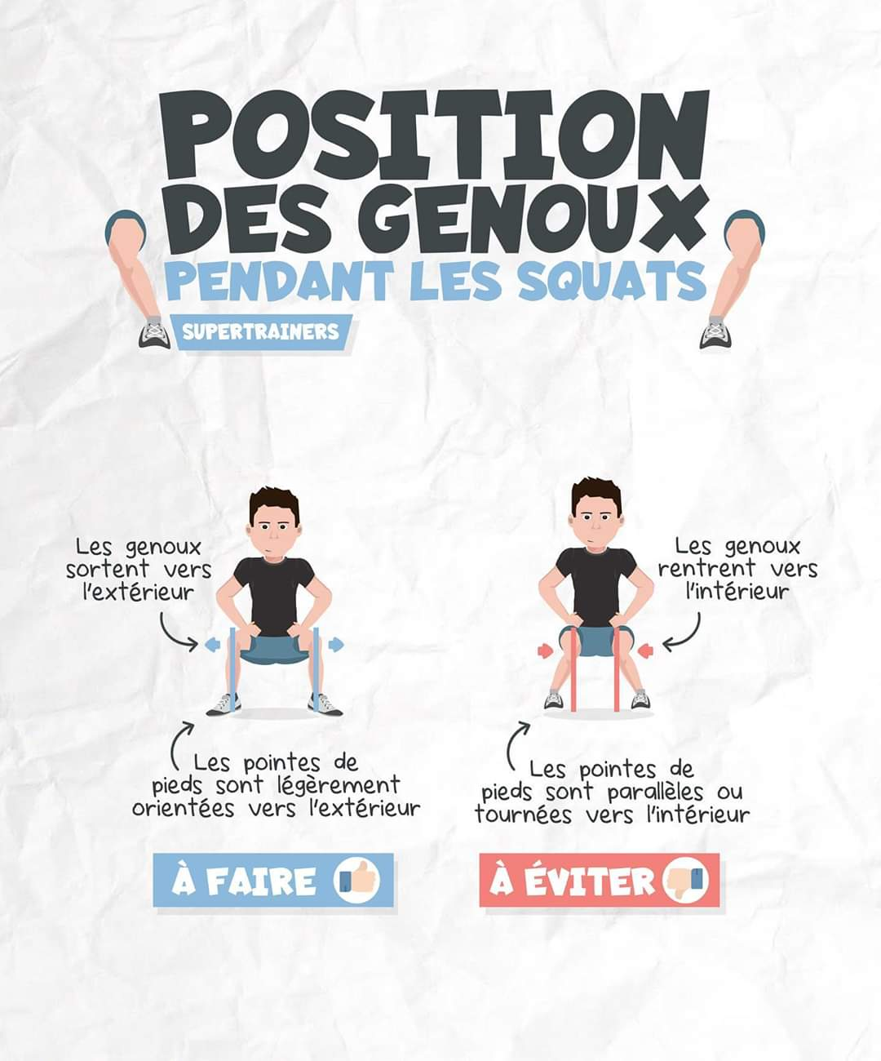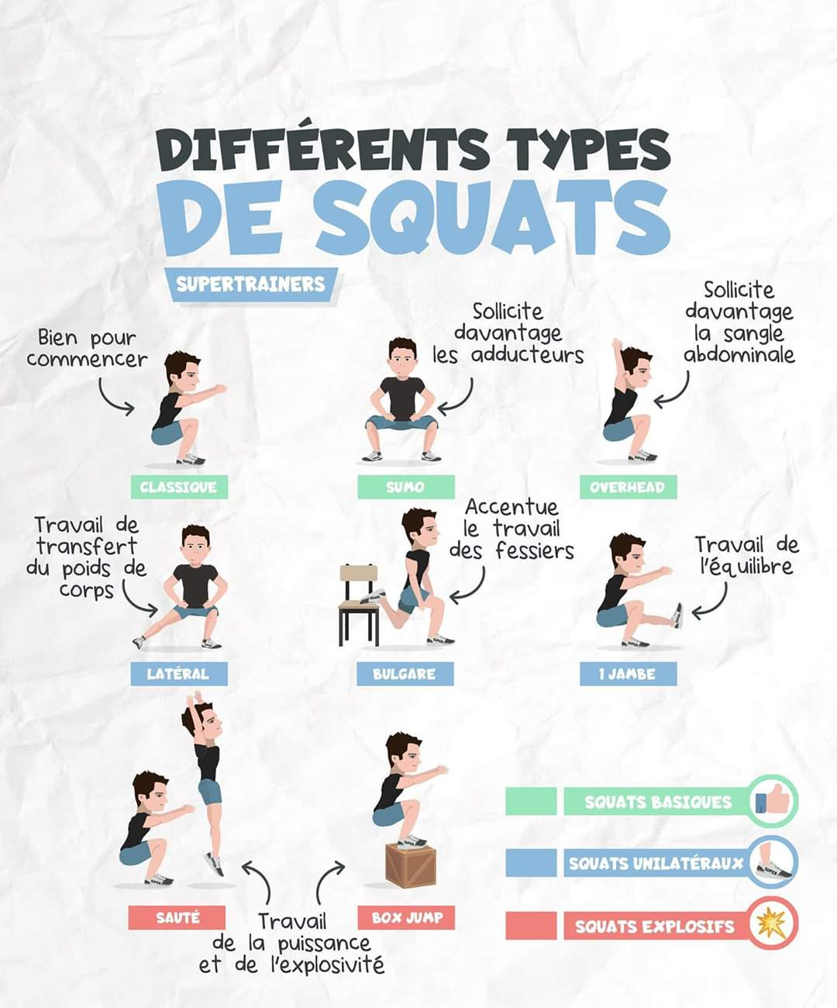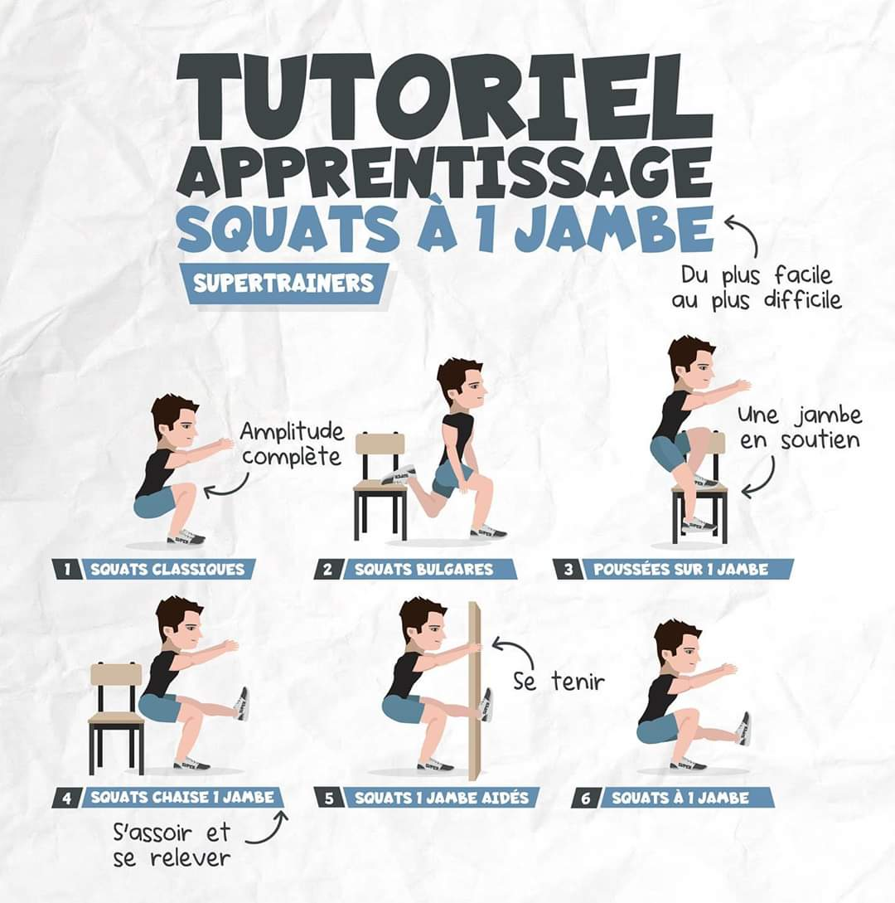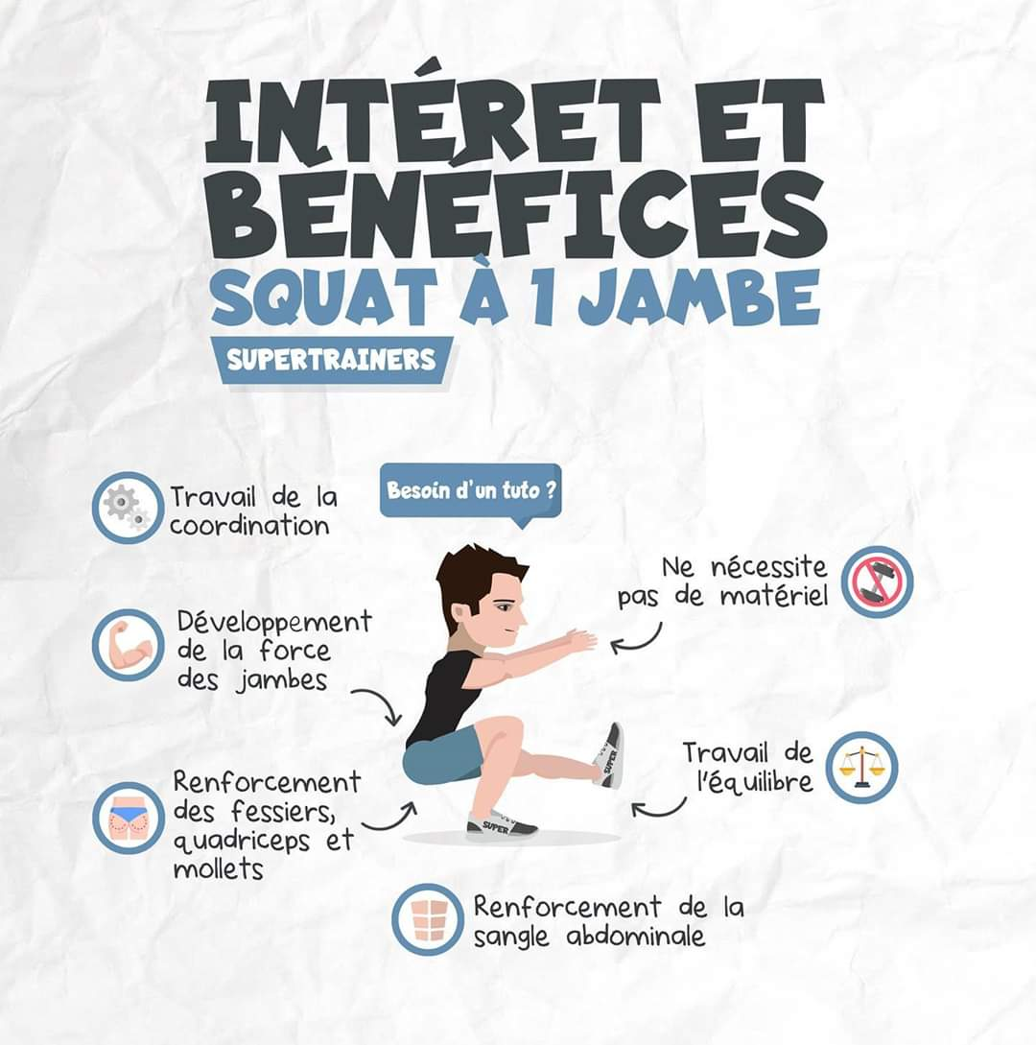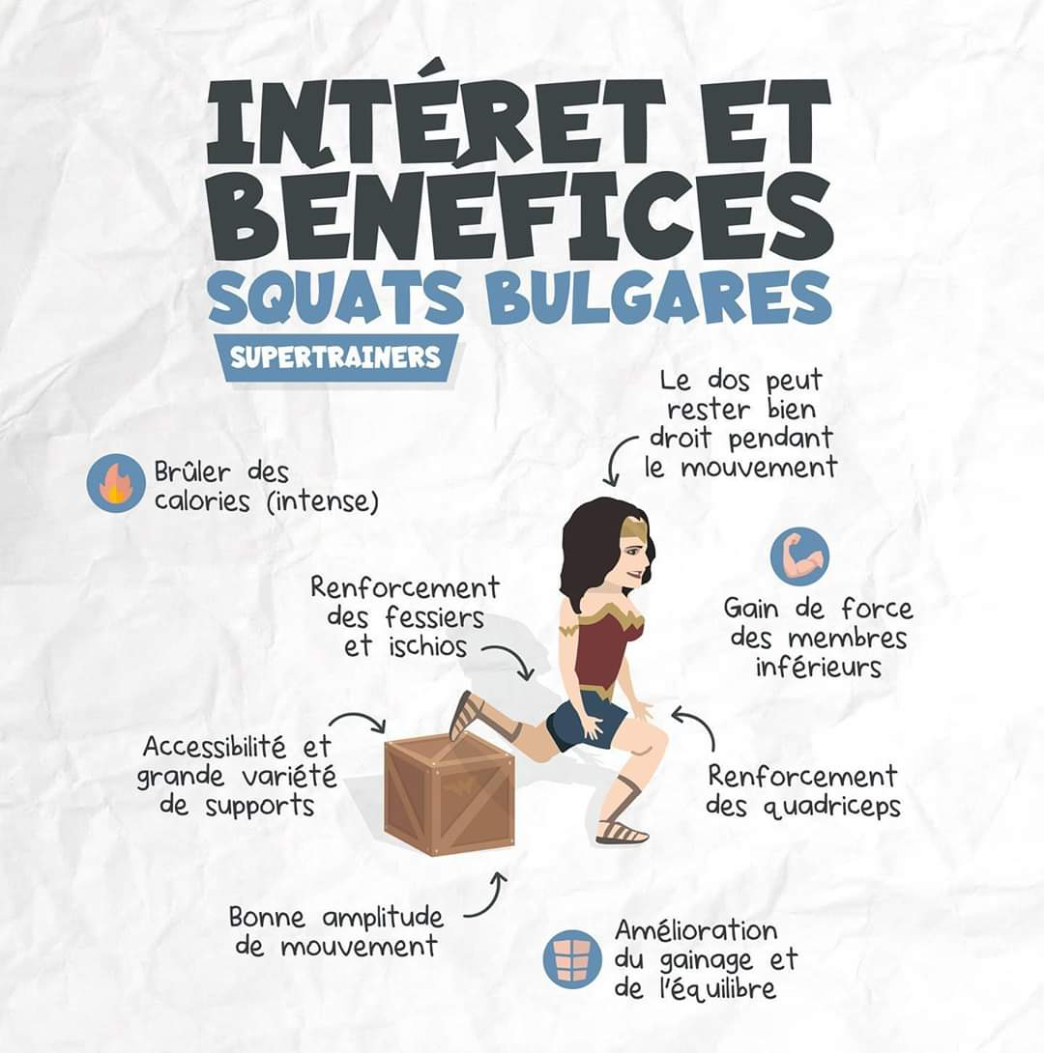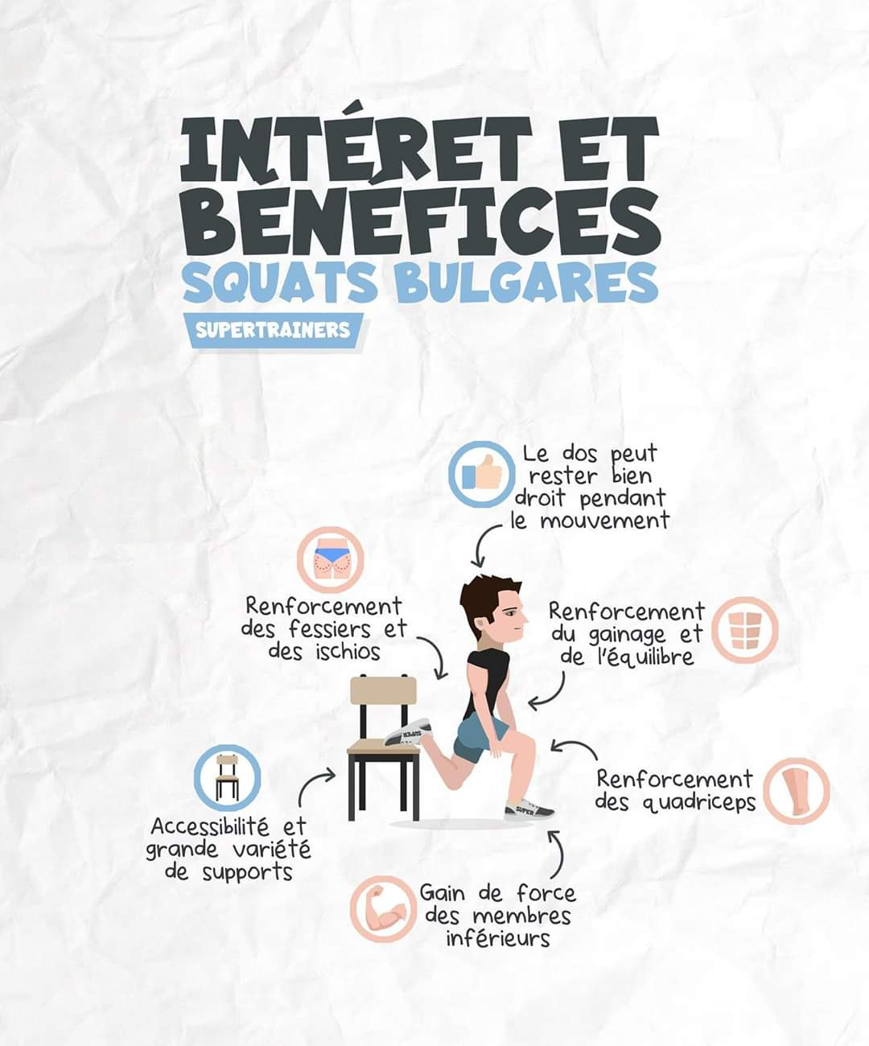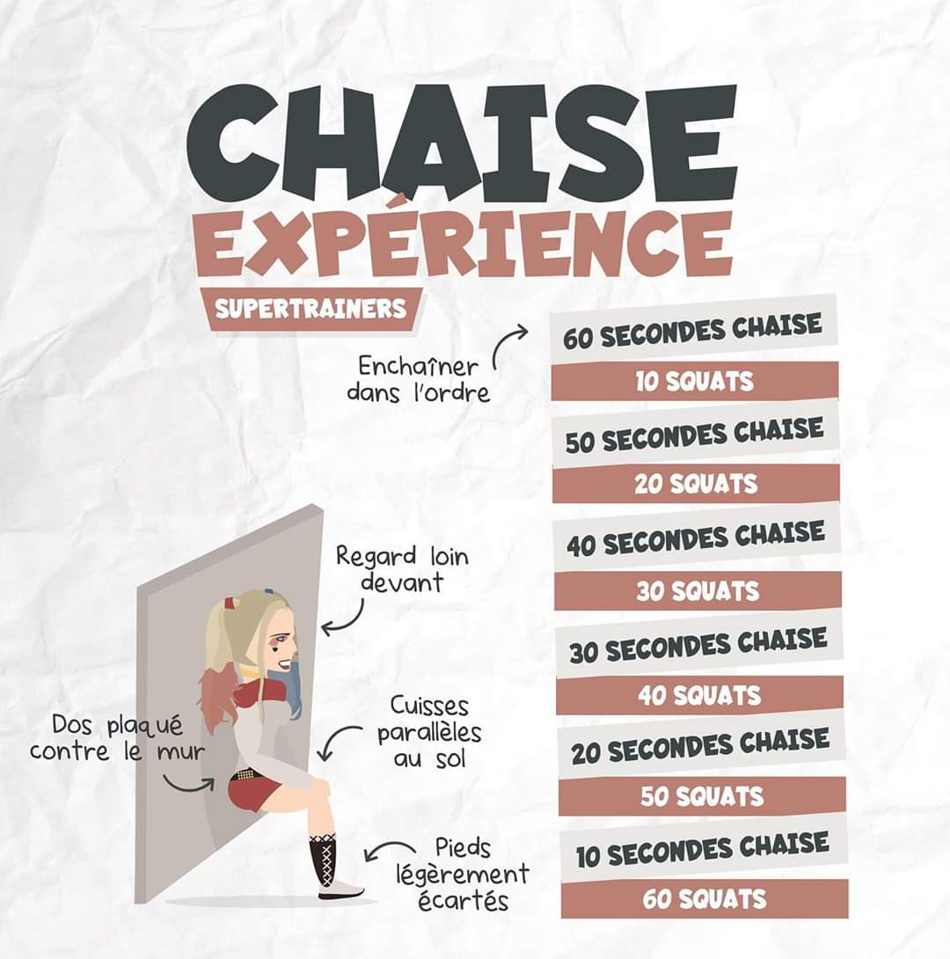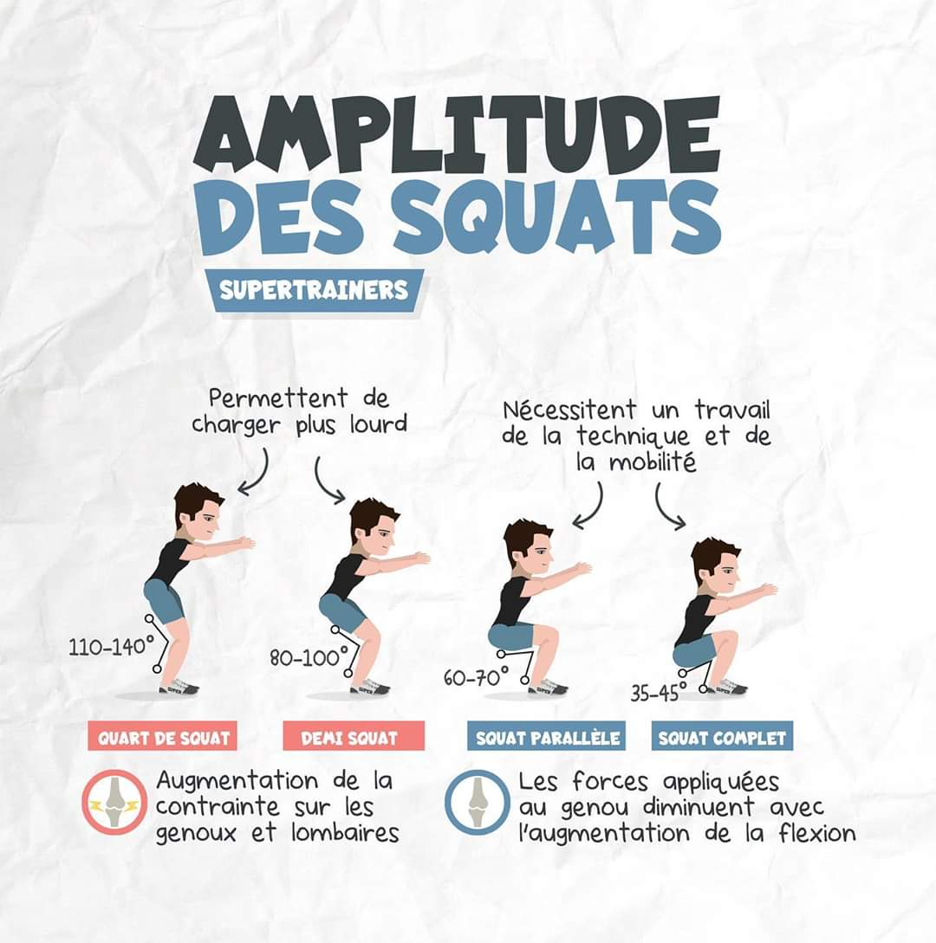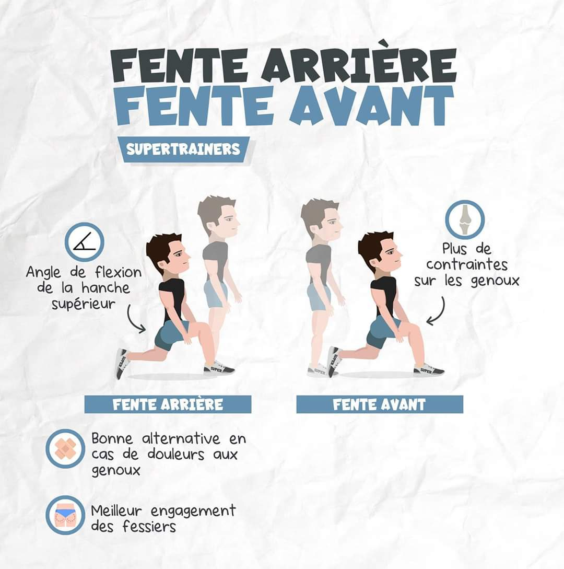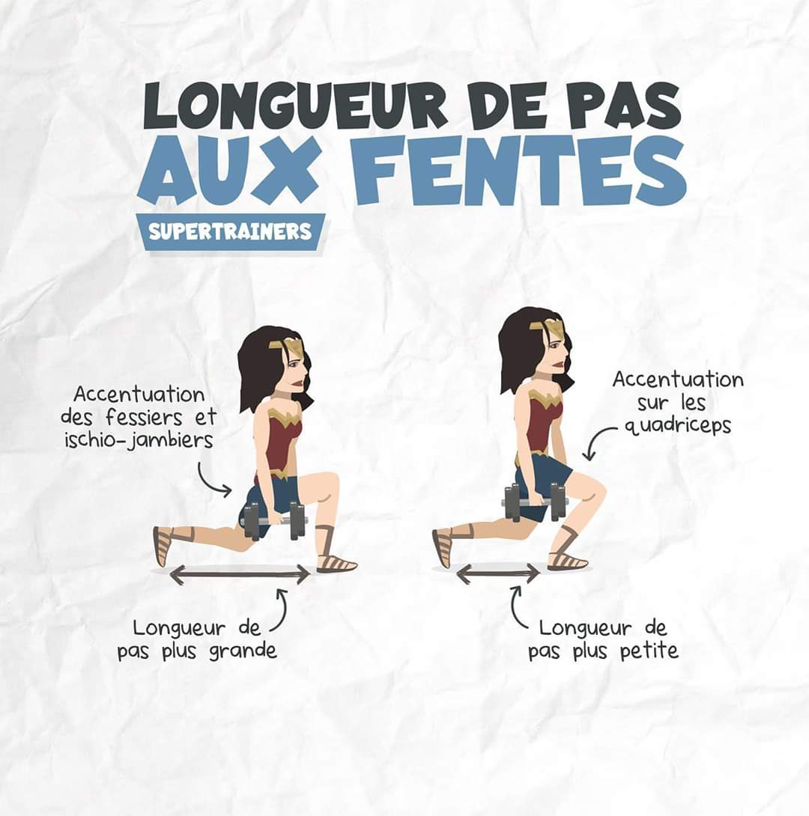
Challenge 30 jours / 30 Squats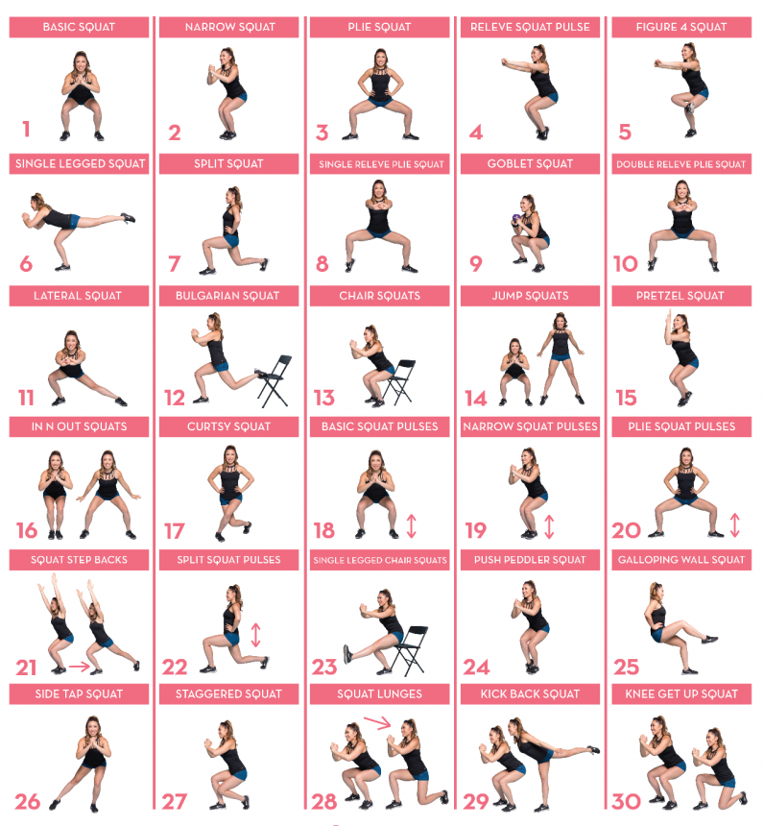
1. Basic squat  2. Narrow squat  3. Plie squat  4. Releve squat pulse  5. Figure 4 squat  6. Single legged squat  7. Split Squat  8. Single releve plie squat  9. Goblet squat  10. Double releve plie squat  11. Lateral squat  12. Bulgarian Squat  13. Chair squats  14. Jump squats  15. Pretzel squat | 16. In n Out Squats  17. Curtsy Squat  18. Basic squat pulses  19. Narrow squat pulses  20. Plie squat pulses  21. Squat Step Backs  22. Split Squat Pulses  23. Single Legged Chair Squats  24. Push Peddler Squat  25. Galloping Wall Squat  26. Side Tap Squat  27. Staggered Squat  28. Squat Lunges  29. Kick back squat  30. Knee Get Up Squat

